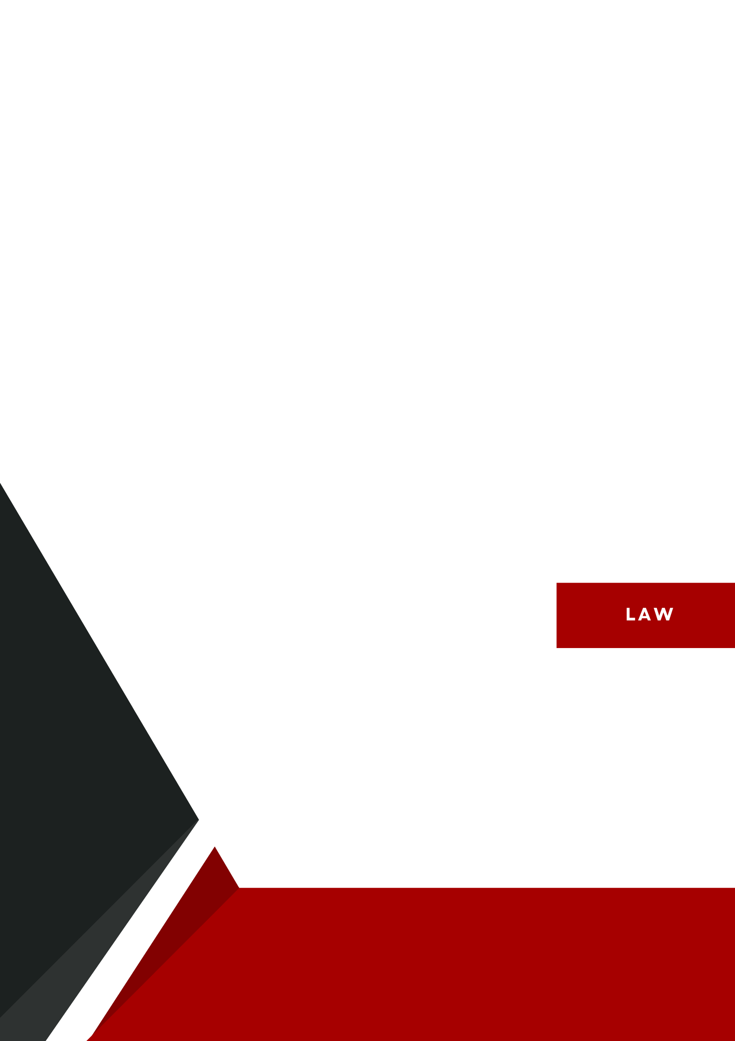

**The Influence of Social Media on Political Mobilization and Public Opinion in Türkiye**

Abstract

Over the last few decades social media has transformed the way politics are conducted in the modern world. It has become a rather crucial platform for politicians to connect directly with their constituents, keeping out of traditional media outlets. Through social media, politicians can share their views, engage in discussions, and respond to the public's concerns. This has democratized the political process, allowing for greater transparency and accountability.

However, the rise of social media has also raised concerns about the spread of misinformation and the potential of political polarization. The ease with which information can be spread online has made it almost impossible to separate fact and fiction. Furthermore, the algorithms utilized by social media sites can create echo chambers in which users are only exposed to content that confirms their preexisting ideas. This can contribute to a deep dividing between different political groups.

Despite these challenges, social media remains a powerful tool for political communication. It has the potential to empower citizens and hold politicians accountable. By understanding the benefits and drawbacks of social media, we can harness its power from the improvement of our democracy.

Political Landscape in Türkiye

Turkey's political landscape is defined by a combination of strong leadership, active political parties, and a history of major political changes. Following the 2018 constitutional referendum, which converted the country's system from parliamentary to presidential, the country currently operates as a republic with a multi-party system, with the president having great power.

President Recep Tayyip Erdoğan leads the ruling Justice and Development Party (AKP), while opposition groups include the Republican People's Party (CHP) and Peoples' Democratic Party (HDP). In recent years, the political climate has been characterized by arguments about democracy, human rights, and freedom of expression, with social media playing an increasingly important role in shaping political discourse and organizing citizens. Political events such as the Gezi Park demonstrations and reactions to government policy have emphasized social media's role in both supporting and criticizing the administration.

The constantly changing interactions between political authority and public speech, particularly via social media, has become a defining characteristic of Turkey's contemporary political scene.

Social Media as a Tool for Political Mobilization

**How social media platforms (e.g., Twitter, Instagram) are used for organizing protests and movements**For the purpose of planning demonstrations and movements, social media sites like Instagram and Twitter have become essential. People can become supporters even in the absence of official leadership by swiftly disseminating information about planned protests through hashtags, shared content, and live updates. For instance, during the Gezi Park protests, Twitter users were able to stay organized and easily track changes in real time by using hashtags like #DirenGezi. People can visually record events through Instagram posts and stories, which keeps them informed and inspired.

**Examples of political mobilization in Türkiye (e.g Gezi Park protests)**The Gezi Park protests (as mentioned previously) in 2013 are one of the most notable examples of political mobilization through social media in Türkiye. What began as a small protest against the destruction of Gezi Park in Istanbul, grew into a nationwide movement, thanks to the use of Twitter and Facebook. Protesters used these platforms to share images, videos, and information about the protests, drawing international attention. Social media helped people gather, share updates on government actions, and stay united even when facing media blackouts or censorship.

**Role of influencers and activists in spreading political messages**In Türkiye, influencers and activists with large followings often play a key role in shaping political discussions on social media. Influential figures like journalists, academics, and cultural figures can quickly spread political messages to their audience, mobilizing public opinion. For example, during times of instability in politics or elections, activists and celebrities use social media to speak out for policies, raise awareness about social concerns, and encourage people to vote. Their voices may be useful to build support for political initiatives and draw attention to key topics that traditional media may overlook.

Impact on Public Opinion

### **How social media shapes public opinion through trending topics and viral content**

In our day, social media plays a great role at shaping public opinion, especially in Turkey. Platforms like X, instagram, and youtube allow information spread in a rapid way, often faster than the traditional news outlets. Trending subjects and viral content grasp attention, making certain political issues, scandals, or social causes dominate the public conversation. For example, when a hashtag related to political topics starts trending, it immediately draws more people into the discussion, whether they agree with it or not. This viral nature makes it easy for certain viewpoints to gain traction, influencing how people feel about political parties, policies or leaders.

Social media also gives people a voice , and a sensation of liberty allowing them to express their opinions and share their very own experiences. When these stories go viral, they can have a huge impact on the broader public conversation. Its not just politicians and journalists who are shaping the narrative anymore, anyone with a smartphone or rather specifically, anyone who can access the internet or the media has the ability to be a part of this political discussion.

### **Comparison between traditional media and social media at influencing people**

While the traditional media, like the TV and newspapers, still hold an important role in shaping public opinion, its influence is slowly being overshadowed by modern social media. Traditional media is often seen as controlled by big corporations or the government, which can lead people to lose trust. In contrast to it, social media is seen are rather democratic on this very topic, anyone can post, share or comment on anything however they will. This openness makes people feel more comfortable and connected to what's happening around and gives them the opportunity to see multiple perspectives of the issue.

However, the social media’s uncensored nature can have both positive and negative aspects. While it allows for rather various opinions, it can also spread misinformation or create echo chambers, where people only see the information that confirms their existing beliefs. Traditional media, by contrast, is usually bound by journalistic standards, which theoretically makes it more reliable. But in Turkey, where media freedom has been a concern, social media has become an even more vital space for alternative perspectives and independent reporting.

**Case studies on recent political events and elections in Türkiye**

Recents elections and political occasions in Turkey have shown how influential social media can be. For example, the 2019 Istanbul mayor elections: the media was a critical battleground, with both candidates and their supporters using it to gather voters, counter misinformation, and keep people engaged. Twitter (now referred to as “X”) became a space for debates, and Instagram was used to share campaign highlights.

Similar to this,in the previous year, during the 2023 general elections, social media platforms were surging with posts about voting, campaign promises and critiques of the political process.

In these contexts, one of the key benefits of social media was its ability to bypass traditional media restrictions. In cases where the mainstream outlets were heavily censored, social media allowed opposition figures to get their messages out to the society. Along with all those, viral videos and memes also had played big roles at influencing voters, often simplifying complex issues into something rather easy to absorb and share.

Positive and Negative Aspect of Social Media Influence

Now, social media, in general , has infinite positive sides as much as its negative aspects. But let's dive deep into a specific genre, our topic, its positive and negative sides on Political Mobilization and Public Opinion in Türkiye.

**Advantages**

One of the biggest advantages of social media in politics is how it increases the awareness of politics. In Türkiye, platforms like Twitter (X) and Instagram have made it much easier for individuals to keep updated about what's happening in the political world. Whether it's a protest, a new policy-law announced or an election, the information spreads rapidly. People don't have to rely on traditional media channels, they can just scroll through their feed and get real-time updates on political events, often straight from those directly involved. Especially among younger generations who might not normally interact with traditional media, this quick access to information has contributed to an increase in political awareness.

Social media also allows for the democratization of opinions. In the past, only a few journalists, politicians, and experts had a platform to share their views, whereas now everyone can have a voice , have their thoughts heard / noticed whether they are an activist, a student, or just a concerned citizen. The variance of opinions can lead to rather vibrant, inclusive political discussions. Given the easy access of their phones, people can question the way things are, offer alternative viewpoints and create communities centered around common interests.

**Disadvantages**

However, social media also has its downsides. A major issue is the spreading of misinformation. Unlike the traditional media, which is based on editorial standards and fact-checking, social media is unsupervised. False or misleading information can spread really quickly, often reaching thousands or even millions of people before it’s corrected. In Türkiye, this has been a particular problem during the elections and political crises, when rumors or fake news can create confusiıon and tension amongst the public.

Another disadvantage is the rise of echo chambers. Social media algorithms tend to show people content that aligns with their existing beliefs, which means they’re less likely to encounter opposing views. This can eventually cause polarization, in which individuals adopt increasingly strong beliefs and show less interest in interacting with others who have opposing views. This polarization has been an increasing problem in Turkey, where social media political discussions can often turn acrimonious and polarizing, leaving little opportunity for fruitful dialogue.

Conclusion

In conclusion, social media has undeniably changed the landscape of political mobilization and public opinion in Türkiye. Platforms like Twitter (X), Instagram and YouTube have given citizens new ways to engage with politics, allowing them to share their thoughts and views, organize protests and raise more awareness about these important issues. The ability to access real-time information and be a part of political discussions democratized the political process, allowing individuals who may not have had a voice in traditional media.

However, social media’s influence comes with its own challenges. It is more difficult to have productive political discussions when there is polarization due to the spreading of false information and the development of echo chambers. Social media nevertheless shows potential and risks for political communication in Turkey, despite these negative aspects. Moving forward, the key will be finding ways to balance the freedom social media offers with the need for accurate information and open, respectful communication.

By understanding both the positive and negative sides of social media’s role in politics, Türkiye can better navigate its influence to strengthen its democratic processes and foster a more informed, engaged public.

**Written By: Defne Göndemir**