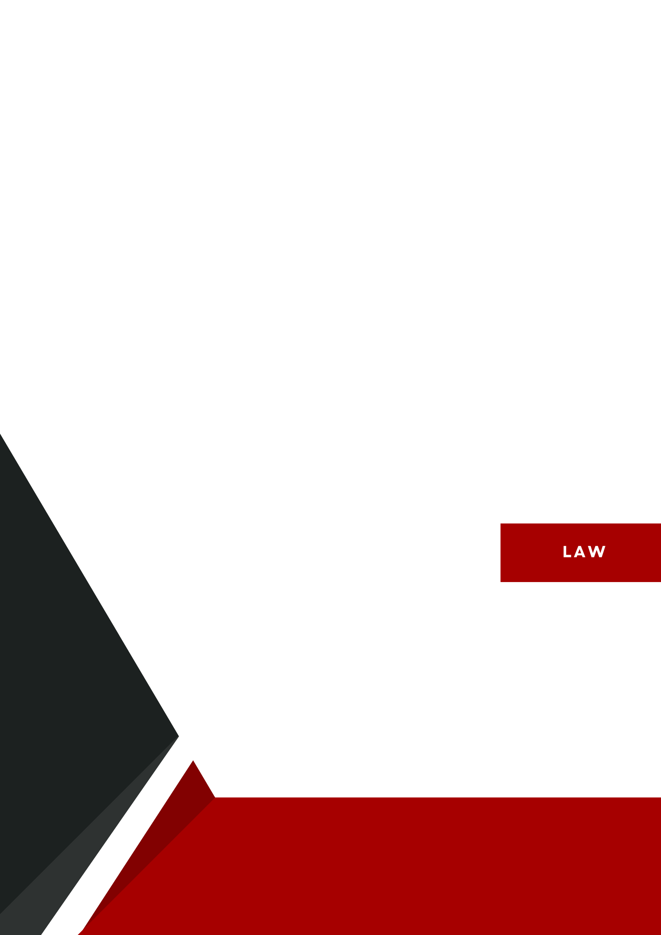

**NAVIGATING MARITIME LAW: ENSURING GLOBAL ACCOUNTABILITY**

**Nazlı Gözi**Abstract

In the current global landscape, maritime law plays a vital role in regulating the vast majority of the world's oceans, which serve as crucial lines for trade, security, and environmental sustainability. With nearly 90% of international trade relying on maritime transport, ensuring accountability within this legal framework is vitally important. However, enforcement faces significant challenges due to jurisdictional overlaps, geopolitical conflicts, and environmental threats. This paper explores the evolution of international maritime law, analyzing key treaties such as the United Nations Convention on the Law of the Sea (UNCLOS) and the role of institutions like the International Maritime Organization (IMO). It further examines contemporary challenges, including piracy, illegal, unreported, and unregulated (IUU) fishing, cyber threats, and the economic burdens of maritime security. Finally, it highlights the need for enhanced technological monitoring, strengthened legal frameworks, and international cooperation to uphold maritime law accountability and ensure sustainable governance of global waters.

Introduction to International Maritime Law

Maritime law has been an essential part of global governance for centuries, evolving from early navigation rules to complex international treaties that regulate the vast expanse of the world's oceans. As over two-thirds of global trade is conducted via maritime routes, the need for a structured and enforceable legal framework has become increasingly significant. The UNCLOS, adopted in 1982, serves as the foundation for modern maritime governance, defining territorial waters, exclusive economic zones (EEZs), and the responsibilities of states regarding resource management, environmental protection, and security.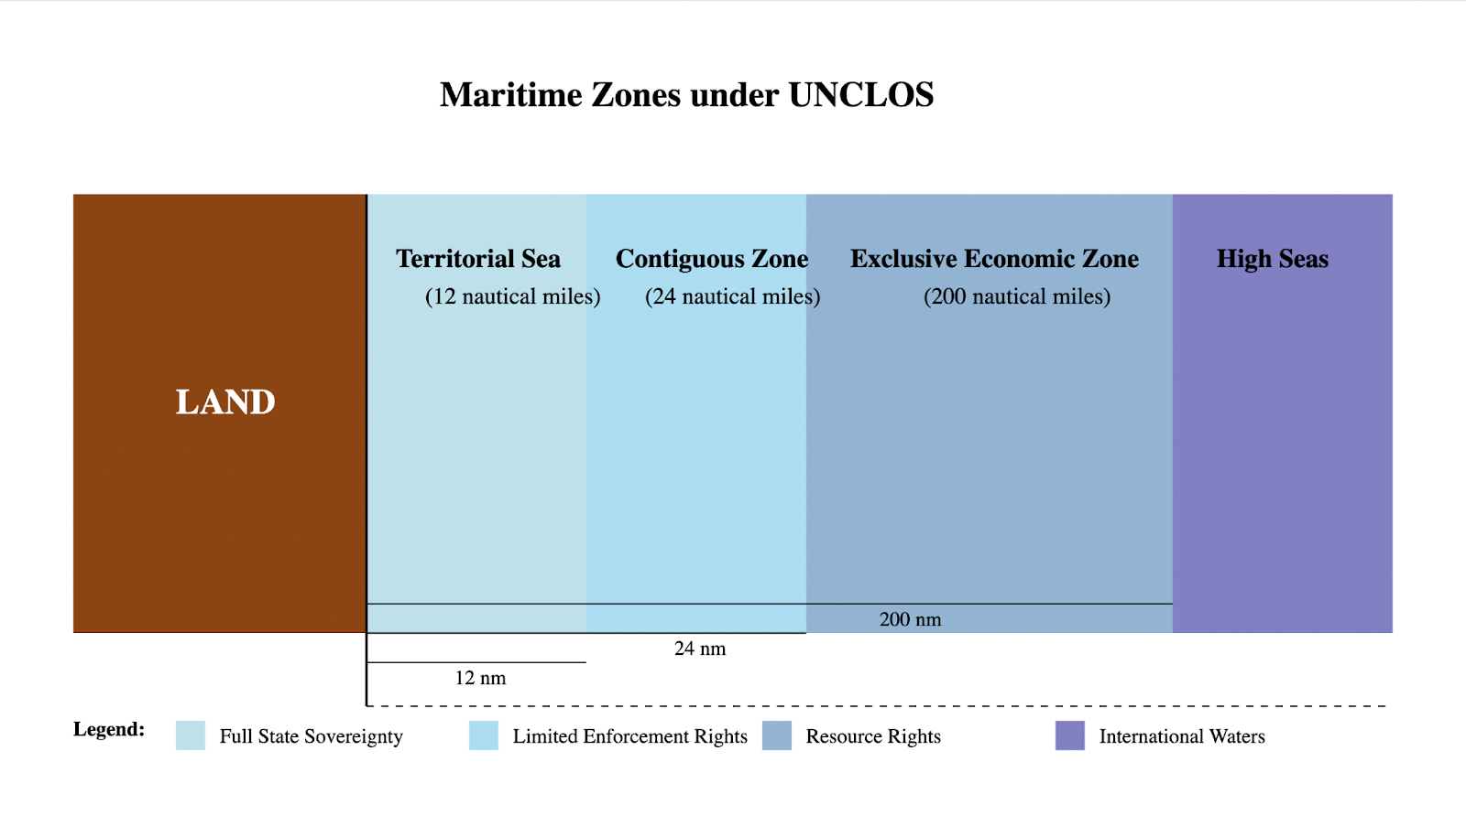

International Maritime Law (IML) addresses not only commercial regulations but also broader concerns such as environmental sustainability, dispute resolution, and transnational crime prevention. Given the complexities of governing the high seas, which fall outside any single nation’s jurisdiction, international cooperation is necessary to ensure compliance and accountability. However, gaps in enforcement, jurisdictional conflicts, and emerging security threats continue to challenge the effectiveness of maritime law. Strengthening legal frameworks, investing in enforcement mechanisms, and fostering global collaboration are crucial to maintaining order and security in international waters.

Key Concepts in Maritime Law

* **Maritime Law:** A comprehensive set of legal principles governing maritime activities, including shipping, navigation, and marine resource exploitation.
* **Flag State Jurisdiction:** The regulatory authority a country exercises over vessels registered under its flag, irrespective of their location.
* **Port State Control:** The right of coastal nations to inspect and regulate foreign vessels entering their ports to ensure compliance with international maritime standards.
* **Exclusive Economic Zone (EEZ):** A maritime zone extending 200 nautical miles from a nation's coastline, granting exclusive rights over marine resources and economic activities.
* **International Maritime Organization (IMO):** A specialized UN agency responsible for setting global maritime safety, security, and environmental standards.
* **Maritime Liability:** Legal frameworks defining responsibility for maritime accidents, environmental damage, and compensation mechanisms.

Challenges in Maritime Accountability

Despite significant international efforts, challenges in maritime accountability persist across various domains. Piracy remains a major threat, particularly in regions such as the Gulf of Guinea and the waters off Somalia. While counter-piracy initiatives, including Combined Task Force 151 and the Djibouti Code of Conduct, have shown success, they suffer from inconsistent funding and enforcement mechanisms.

Illegal, unreported, and unregulated (IUU) fishing continues to devour marine ecosystems and disrupt local economies, particularly in coastal developing nations. Although agreements like the Port State Measures Agreement (PSMA) exist to combat IUU fishing, a lack of technological oversight and uneven national enforcement weakens their effectiveness. 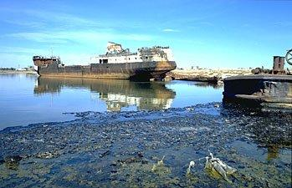

Environmental protection and liability present another challenge, with major environmental disasters such as oil spills and industrial waste dumping exposing failures in maritime regulatory enforcement. Treaties like MARPOL attempt to regulate pollution, but the enforcement inconsistencies across different jurisdictions lead to it being ineffective.

Additionally, maritime territorial disputes, such as those in the South China Sea, continue to complicate maritime law enforcement. Despite the legal framework provided by UNCLOS, geopolitical rivalries frequently obstruct compliance and peaceful dispute resolution.

Emerging technological threats, including the rise of autonomous shipping and cyber risks such as GPS spoofing and hacking of maritime navigation systems, further deepen accountability concerns. As maritime operations become increasingly reliant on digital infrastructure, existing legal frameworks must evolve to address new security risks and liability concerns.

Current Framework, Regional Disparities, and Economic Burden

While UNCLOS provides the foundational structure for maritime governance, enforcement varies significantly across regions. In Europe, the European Maritime Safety Agency (EMSA) ensures strict maritime safety protocols, while West Africa faces considerable challenges due to limited resources and political instability. Southeast Asia has made strides in regional cooperation through initiatives like the Regional Cooperation Agreement on Combating Piracy and Armed Robbery against Ships (ReCAAP), yet jurisdictional complexities continue. In the Arctic and polar regions, the rapid melting of ice caps has not only opened new shipping lanes but also introduced territorial disputes and environmental concerns that complicate governance.

Maritime accountability also imposes substantial financial burdens, with costs extending to port security infrastructure, heightened insurance premiums for high-risk areas, and law enforcement operations. These expenditures disproportionately impact developing nations, where resource constraints hinder effective enforcement, leaving gaps that criminal enterprises exploit. As a result, disparities in maritime governance exacerbate global security risks and economic vulnerabilities.

Conclusion

Maritime law has continuously evolved to address the dynamic challenges posed by global trade, environmental sustainability, and security concerns. As the backbone of international commerce and a key pillar of global stability, maritime law ensures the orderly use of the world's oceans while promoting cooperation among nations. The implementation of key treaties such as UNCLOS has laid a strong foundation for ocean governance, providing clarity on territorial waters, navigation rights, and environmental responsibilities. Despite these advancements, enforcement disparities, and jurisdictional conflicts remain a persistent challenge, requiring adaptive legal frameworks and strategic diplomatic engagements.

The interdependence of nations on maritime trade underscores the importance of collaborative governance and mutual accountability. Emerging technological advancements, such as AI-driven tracking systems and satellite surveillance, provide promising avenues to enhance law enforcement and minimize violations. Additionally, strengthening regional cooperation through multinational agreements can bridge enforcement gaps and create a unified approach to maritime security. Economic investments in sustainable port infrastructure, eco-friendly shipping practices, and resilient coastal protections will further reinforce maritime stability for future generations.

Ultimately, while challenges remain, the future of maritime governance offers opportunities for greater accountability, innovation, and sustainability. Through unwavering commitment to international cooperation, legal reforms, and responsible stewardship of marine resources, nations can work toward a more just and secure maritime environment. By embracing adaptability and progressive policy-making, the global community can ensure that the world's oceans continue to serve as a conduit for peace, prosperity, and environmental harmony for generations to come.

Sources

"Aral Sea (lake, Central Asia) | Britannica." *Encyclopedia Britannica*, 2021, www.britannica.com/place/Aral-Sea/images-videos#/media/1/31983/8525. Accessed 21 Jan. 2025.

International Maritime Organisation. "International Convention for the Prevention of Pollution from Ships (MARPOL)." *International Maritime Organization*, 25 Dec. 2024, www.imo.org/en/about/Conventions/Pages/International-Convention-for-the-Prevention-of-Pollution-from-Ships-(MARPOL).aspx. Accessed 15 Jan. 2025.

Kara, Hacı. *Deniz Ticareti Hukuku*. 1456 ed., onikilevha, 2014

Schechter, Shaffer and Harrid. "What Is International Maritime Law?" *Maintenance and Cure*, 6 June 2024, maintenanceandcure.com/maritime-blog/what-is-international-maritime-law/. Accessed 20 Jan. 2025.